**Unit 6**　**Meet My Family!**

Part B (3)

一、开动脑筋，你来写。(20分)

1.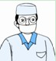　　　　　　　 2.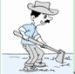

3.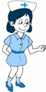　 　 4.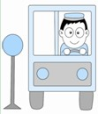

5.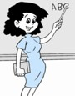

语句 应用练

二、连词成句。(35分)

1．come，my，meet，and，family(.)

2.they，drivers，are(？)

3.like，a，nurse，act(.)

4.who，woman，that，is(？)

5.do，a，sister，have，you(？)

阅读 理解练

三、阅读短文，判断正(**T**)误(**F**)。(25分)

My name is John.I am a boy.There are four people in my family.They are my father, my mother，my sister and me.My mother is a nurse.She likes music.My father is strong.He likes sports.My sister is a student.She likes computer games.I love my family.

(　　)1.John is a girl.

(　　)2.There are four people in John's family.

(　　)3.John's mother is a teacher.

(　　)4.John has a sister.

(　　)5.John's father likes computer games.

C部分 拓展练

四、你来填。(20分)



grandpa　 grandma

1．f____ 2.m____ uncle aunt

3．b____ 4.s____　　　　me

My Family Tree

**答案**

一、1.doctor　2.farmer　3.nurse 4．driver　5.teacher

二、1.Come and meet my family.

2．Are they drivers?

3．Act like a nurse.

4．Who is that woman?

5．Do you have a sister?

三、1.F　2.T　3.F　4.T　5.F

四、1.father　2.mother　3.brother　4.sister